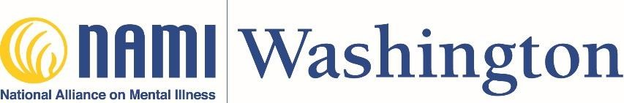

Job Announcement: Training Department Field Placement

Who We Are
The National Alliance on Mental Illness (NAMI) is the nation's largest grassroots mental health organization dedicated to building better lives for the millions of Americans affected by mental illness. The NAMI organization operates at the national, state, and local level. At NAMI Washington, we envision a world where all those impacted by mental health conditions know they are not alone, and are empowered to live their most fulfilling life. We are the state office, working to provide support, education, and changes in policy at all levels to ensure better treatment, access, and a behavioral health system to meet the needs of all Washington state residents whose lives are affected by mental health conditions.

Position Summary
NAMI Washington has a field placement opportunity with our Training Department. This position will work with our Sr. Training Manager to implement NAMI Signature Education Program Leader Training weekends and create the NAMI Provider Expansion program. Stipends at the end of their internship between $750-$1000 depending upon the ability of the org to pay.
This will be accomplished by:
- Promoting training opportunities with affiliates and the public at large
- Processing training applications and schedule or conducting interviews of applicants
- Staffing weekend training workshops as needed, either in person or virtually
- providing resources and support before, during, and after weekend training workshops
- working with the Sr. Training Manager, Director of Community Programs, and Executive Director to create and implement the NAMI Provider program expansion

Responsibilities:
Scheduling & Facilitation
- Schedule trainers
- Facilitate Leader Training workshop weekends as the Producer, managing the online space and technology as well as supporting State Trainers and stepping in if challenges arise.
- Document issues for Provisional or Non-Certification and notify Senior Training Manager.
- Become trained in any NAMI Signature Education program for which qualifications are met and interest and time permit
- Ensure evaluations by participants are completed with a goal of 100% participation
- Report data and work with NAMI WA Operations & Data Manager when needed
- Assist with the pretraining steps, such as online Learning training, Pre-Training Interviews, and Pre-Training
Meetings
- Support Affiliates with the application process and other aspects related to NAMI Signature Education Programs
- Assist with tracking systems within the NAMI and NAMI WA Education Training Department
- Understand NAMI Provider program, and work with team to create and implement expansion plan.

Agency Related Responsibilities
- Work closely with the NAMI Washington Senior Training Manager, who will serve as your task supervisor.
- Report program data including number of participants, meetings, events, demographics, and volunteer hours.
- Assist with organizational wide events (Lobby Day, Annual NAMI Washington Conference, NAMIWalks Washington, Brainpower Chronicles), as assigned.
- Conduct other duties as directed by your task manager and MSW supervisor.
- Attend other NAMI Washington and community training opportunities as requested or offered.

